Learner’s Academy

**Back Ground**: Learner’s Academy is a school that has an online management system. The system keeps track of its classes, subjects, students, and teachers. It has a back-office application with a single administrator login.

**Developer**: Meghana ([megs.m9797@gmail.com](mailto:megs.m9797@gmail.com))

**Sprints**:

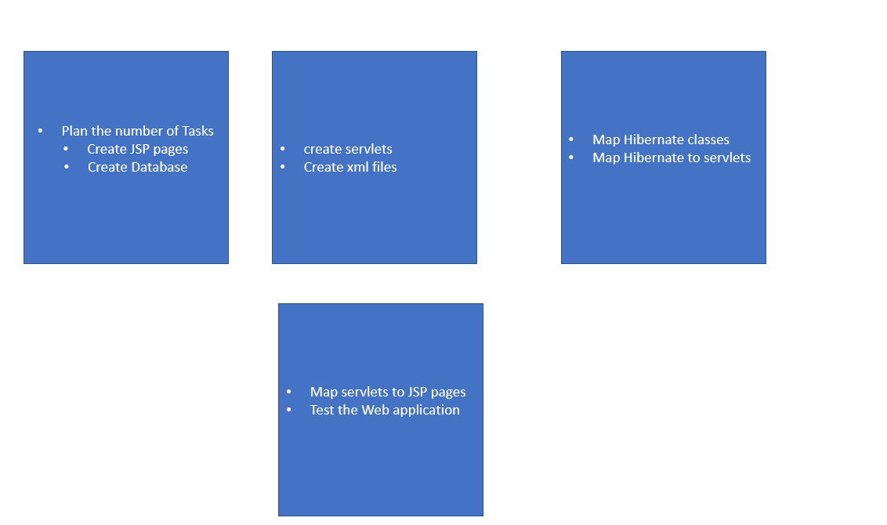

**Algorithm:**

Step 1: Admin login

Step 2 : Choose options from the below

Step 3: [Add Teacher Details](http://localhost:8080/Project/teacher.jsp)

Step 4: [View Teacher Details](http://localhost:8080/Project/ViewTeacher.jsp)

Step 5: [Add Student Details](http://localhost:8080/Project/student.jsp)

Step 6: [View Student Details](http://localhost:8080/Project/ViewStudent.jsp)

Step 7: [Assign Subjects to Class](http://localhost:8080/Project/class-subject.jsp)

Step 8: [List of Classes and Subjects](http://localhost:8080/Project/ViewClassSub.jsp)

Step 9: [Assign Teacher to Subject](http://localhost:8080/Project/teachersubclass.jsp)

Step 10: [View Class Report](http://localhost:8080/Project/Classreport.jsp)

Step 11: Close

Flowchart:

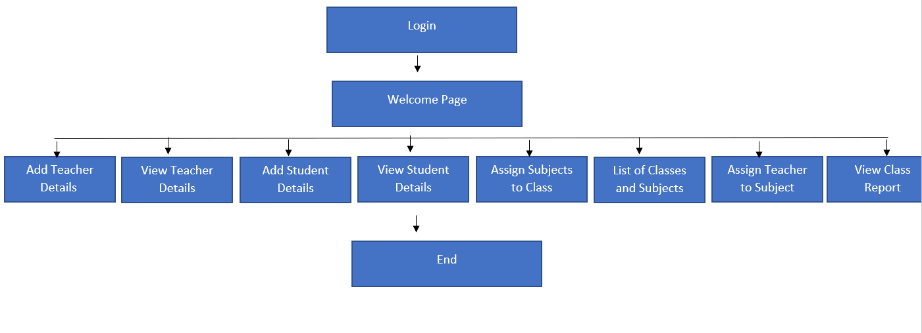

Core-concepts: Java, JSP, Servlets, JDBC, Hibernate, Mysql

GitHub link: https://github.com/Meghana9892/Backend-Expert-Project.git